Cost-push and Demand-pull Inflation Notes:
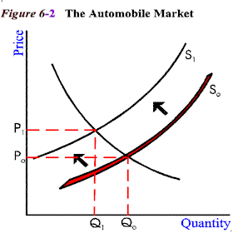
Cost Push Inflation

AD
Output and employment (Real GDP)
AS
AS1
Price Level
Y1
Y
PL1
PL

Demand Pull Inflation

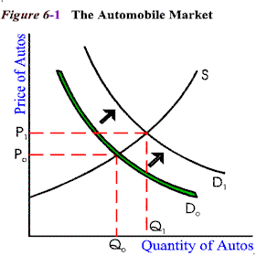
Output and employment (Real GDP)
Y1
AD
AD1
AS
Price Level
PL1
PL
Y

CAUSES OF INFLATION: COPY notes
Causes of Cost Push Inflation:
- Wages and salary increases
- Increase in raw materials
- Government changes (indirect taxes or fees)
Causes of Demand Pull Inflation:
- Rising household incomes due to direct tax cuts, increased transfer payments and wage increases
- Increased investment by business due to lower interest rates or more confidence in the future prospects of the country
- Export boom due to the depreciation of the exchange rate OR
- Expansionary fiscal policy i.e. a Government budget deficit

